# Name Luwei Wang, Vincent Xu Date 12/19/2024

# NYU ID N17988219, N13337595

# NetID lw3511, yx2021

# Course Section CSCI-GA.2622-001

# **Assignment 8: Final Project**

# _____ Part 3 functionality [Max 70 points]

# _____ Part 4 functionality [Max 25 points]

# _____ Style [Max 5 points]

# _____ Part 3 extra credit questions [Max 20 points (10 each)]

# _____Total [Max 100 points + Extra Credit points]

# Total in points:

# Total in extra credit points:

# Professor’s Comments:

# 

# **Affirmation of my Independent Effort: Luwei Wang, Vincent Xu**

## 

## Introduction

The network layer, part of the OSI and TCP/IP models, handles point-to-point data transmission and is divided into the control plane and data plane. The control plane determines the best paths using routing algorithms, while the data plane forwards packets based on routing tables.

Traditional networks have a decentralized control plane in each router, which makes path computation complex and inefficient. Routing tables are limited to network-layer forwarding and are non-programmable. Software Defined Networking (SDN) addresses these issues by centralizing the control plane into a controller, allowing for direct programmability and the generation of flow tables for each device using custom algorithms.

Flow tables support not only network-layer forwarding but also other functionalities like switching, load balancing, and firewalls. Using a "match + action" model, they match packet headers to rules and execute corresponding actions, enabling high programmability across multiple layers.

This project focuses on using SDN to implement Layer-3 routing and load balancing. Layer-3 routing computes forwarding rules based on network topology, while load balancing routes TCP SYN messages and rewrites addresses to resolve paths efficiently.

## Algorithms and Solutions

### 2.1 Layer-3 Routing

The core factor in this part is the shortest path algorithm to calculate optimal routes between each pair of switches. First, get the table of active hosts and links, then adapt the Bellman-Ford Algorithm to find the shortest path from the single source to all of the other destinations and construct the routing table.

Bellman-Ford Algorithm maintains a distance table from the single source node to all of the other nodes in the network. First, initialize the length from the source host to all of the other nodes to positive infinite, then start relaxation.

There will be at most V rounds of relaxation. V is the number of hosts in the network. In each round, traverse all of the links and update the cost of the links if the cost of its predecessor link plus the weight of the link is smaller than the current cost, record the predecessor node as well. The process of updating is called relaxation. Since all of the distances are larger than zero, so there will not be any negative cycle, which means the algorithm could always stop with a proper distance table.

Function getShortestPaths(srcSwitch, links, switches):

distTo = Map<Long, Integer> // Map of switch ID to distance

edgeTo = Map<Long, Integer> // Map of switch ID to predecessor's port

For each switchId in switches.keys():

distTo[switchId] = INFINITY

distTo[srcSwitch.id] = 0

# Perform |V| iterations to relax all edges

For iteration from 0 to (number of switches - 1):

For each link in links:

src = link.source

dst = link.destination

# Relax edge src -> dst

If distTo[dst] > distTo[src] + WEIGHT:

distTo[dst] = distTo[src] + WEIGHT

edgeTo[dst] = link.destinationPort

# Relax edge dst -> src (because the graph is bidirectional)

If distTo[src] > distTo[dst] + WEIGHT:

distTo[src] = distTo[dst] + WEIGHT

edgeTo[src] = link.sourcePort

After obtaining the distance table of the single source host, traverse the host list. For each host in the list, match the shortest path, and update the routing table.

### 2.2 Load Balancing Routing

Load balancing is a technique for distributing network traffic across multiple servers or paths to optimize resource utilization, improve response times, and enhance the high level system reliability. By dynamically analyzing server capacity, current load, and network conditions, load balancers ensure that no single server or route becomes overwhelmed, reducing the risk of downtime or bottlenecks. This is crucial for maintaining consistent performance in environments with high traffic or fluctuating demands.

The load balancers in this project are assigned virtual IP addresses and MAC addresses and act differently depending on the protocol of the received packets. Load balance routing should process both ARP requests for virtual MAC addresses in the Network layer and TCP requests in the Transport layer, by adding different rules in the routing table.

When receiving an ARP protocol packet, the load balancer should match ARP and ARP.TPA, match IPv4 and IP, then reply. When receiving a TCP-SYN request, the load balancer should modify the destination address of the packet to forward it to the assigned real server and set up the TCP connection. The idle time was set to 20 seconds, which means the connection will be closed if there is no action in 20 seconds since the connection was set up. When receiving TCP packets with other flags, send a TCP RESET reply. For any other packets, ignore them.

## Implementation

### 3.1 Layer-3 Routing

The implementation of the Bellman-Ford algorithm is in the figure below:

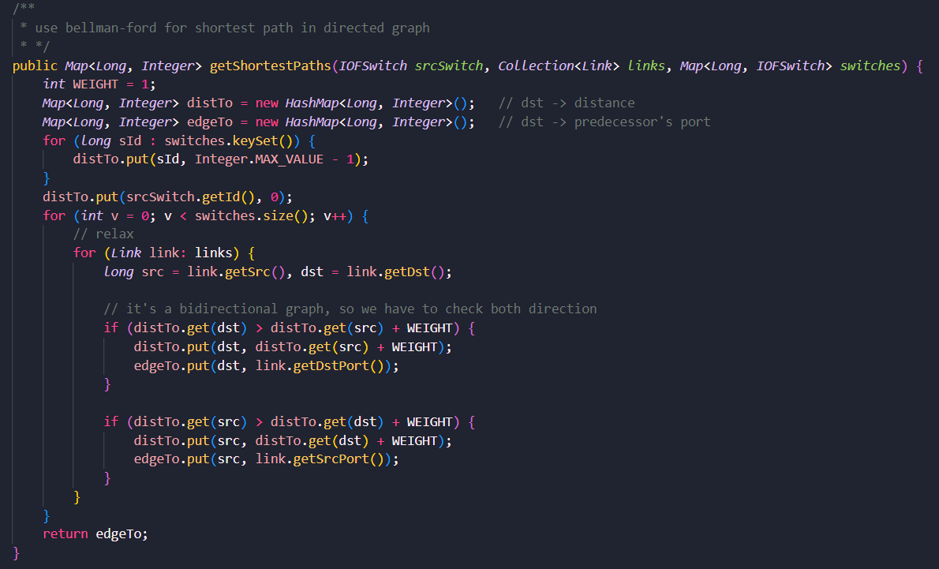

The links in the network can forward packets in both directions, which should be divided into two edges in the direct graph. So for each link, do relaxation on both sides.

Following is the implementation of updating the routing table:

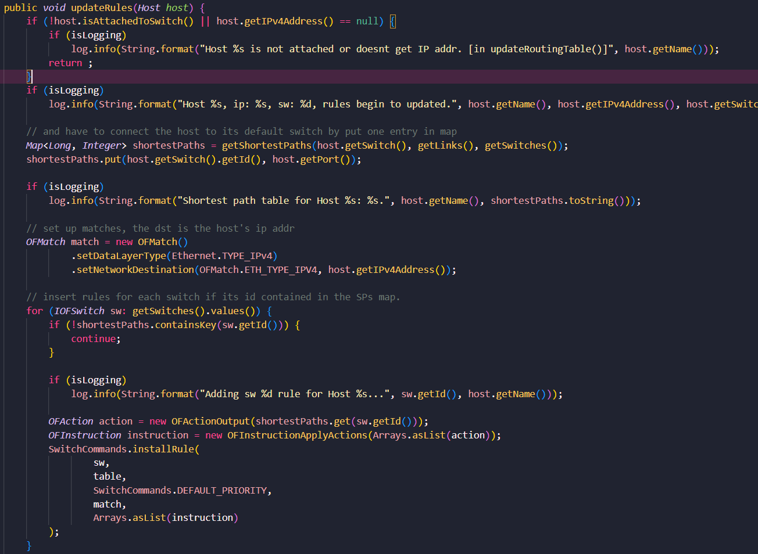

Every time when the known network changes, the routing table will be updated. After obtaining the shortest path from the source host to all the other destinations, update the rule correspondingly and show the update procedure in the log.

### 3.2 Load Balancing Routing

When receiving the packet with protocol ARP:

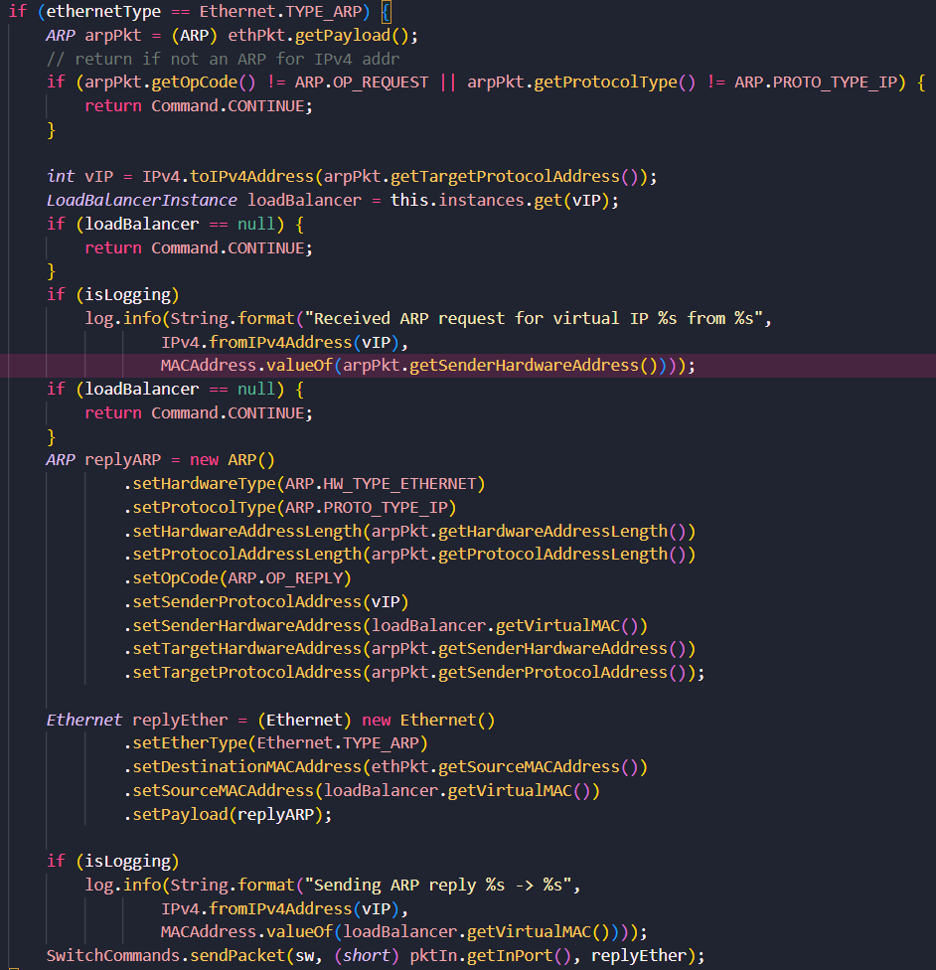

When receiving an ARP packet, extract the destination IP and match it with existing load balance instances’ virtual IPs. When the matching is successful, create a replying ARP packet with the virtual MAC address, and send it to the source host.

All of the rules added in this section have higher priority than the default rules.

When receiving TCP-SYN packets:

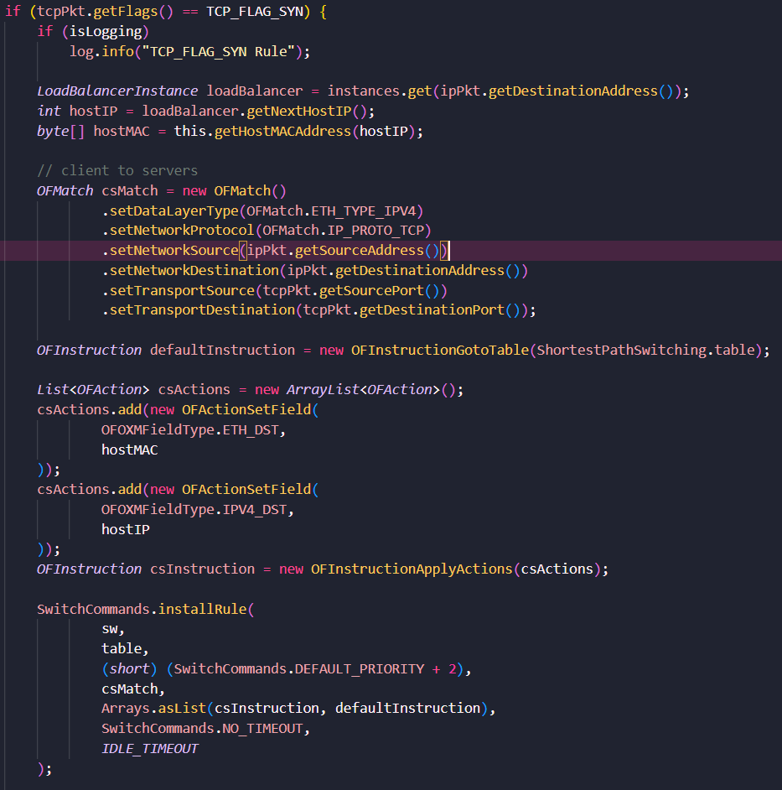

If the source host is the client, change the destination address to the real controller’s address and add the routing rule to the routing table, and set the idle time. Delete the record if no action was taken during the period.

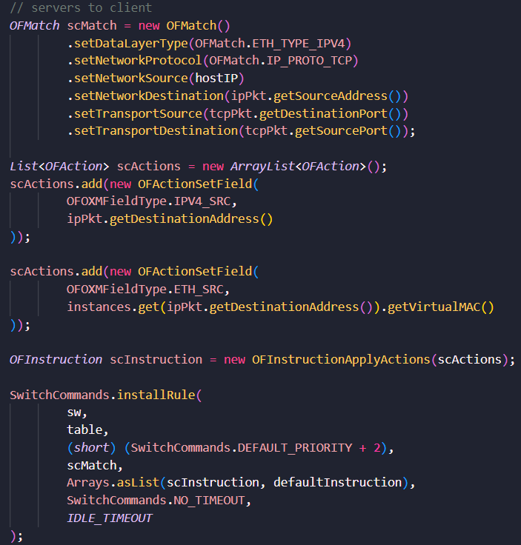

If the source host is a server, change the destination address to the real client host’s address and add the routing rule to the routing table, and set the idle time. Delete the record if no action was taken during the period.

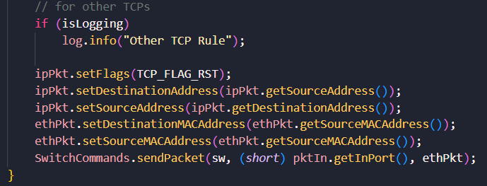

Send TCP RESET reply for all of the other TCP packets.

## Result

Compile project using `ant`:  
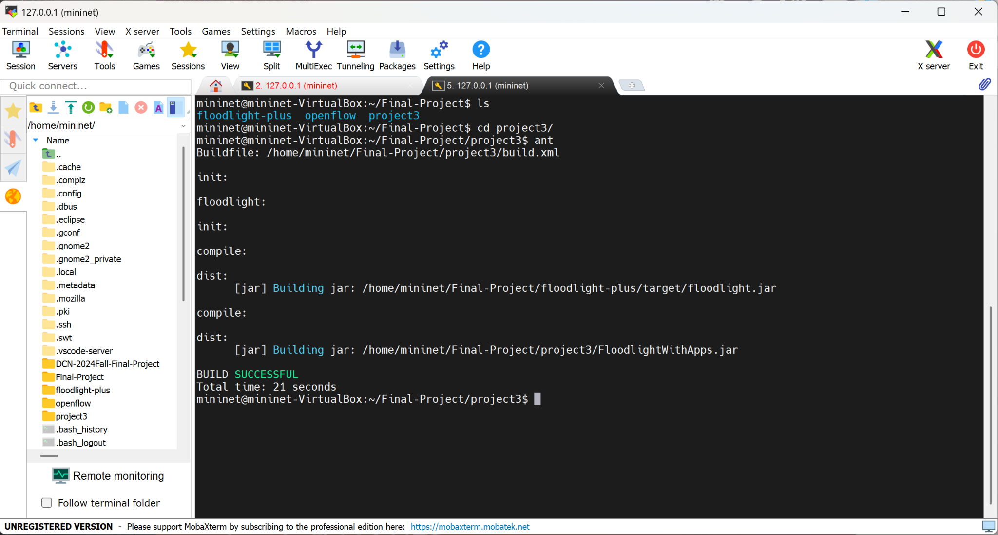

Start Floodlight with only `sps.prop`:

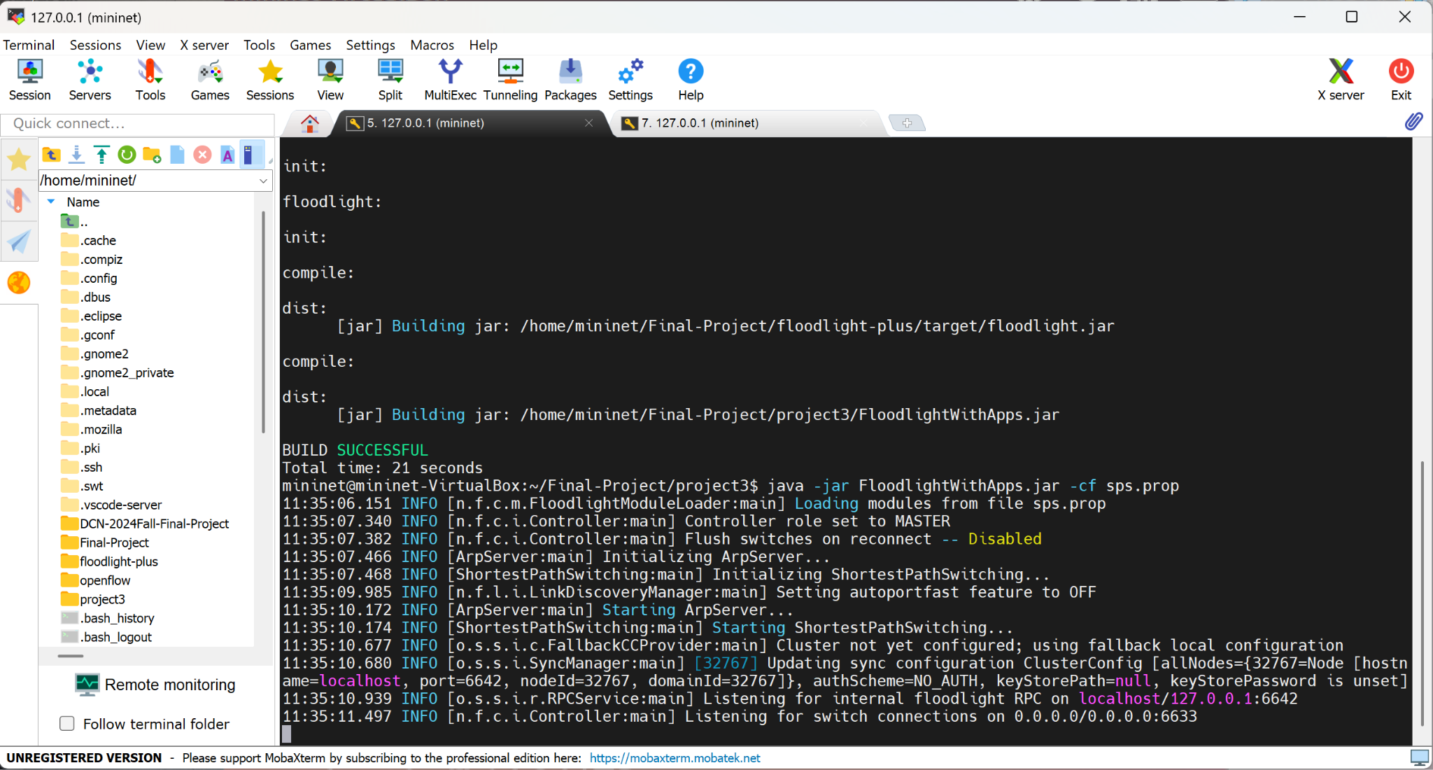

Start mininet with Linear,3 and run `pingall`:

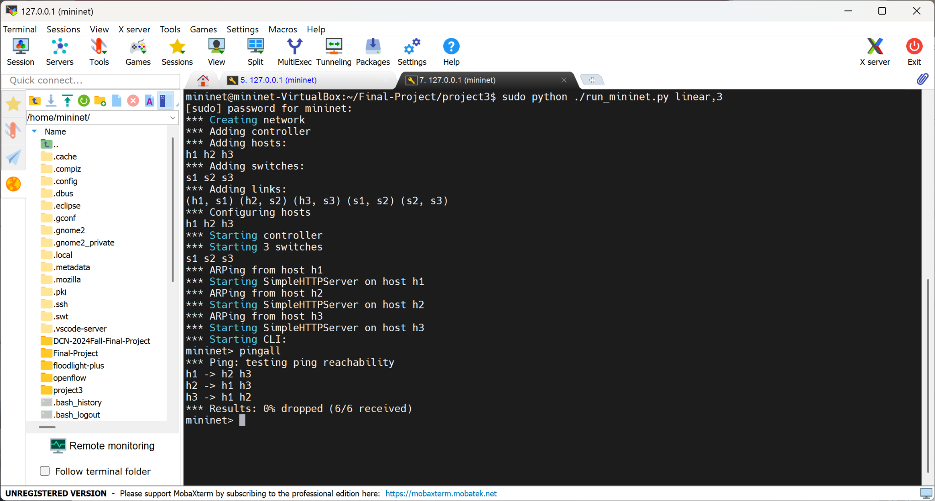

Corresponding Floodlight log:

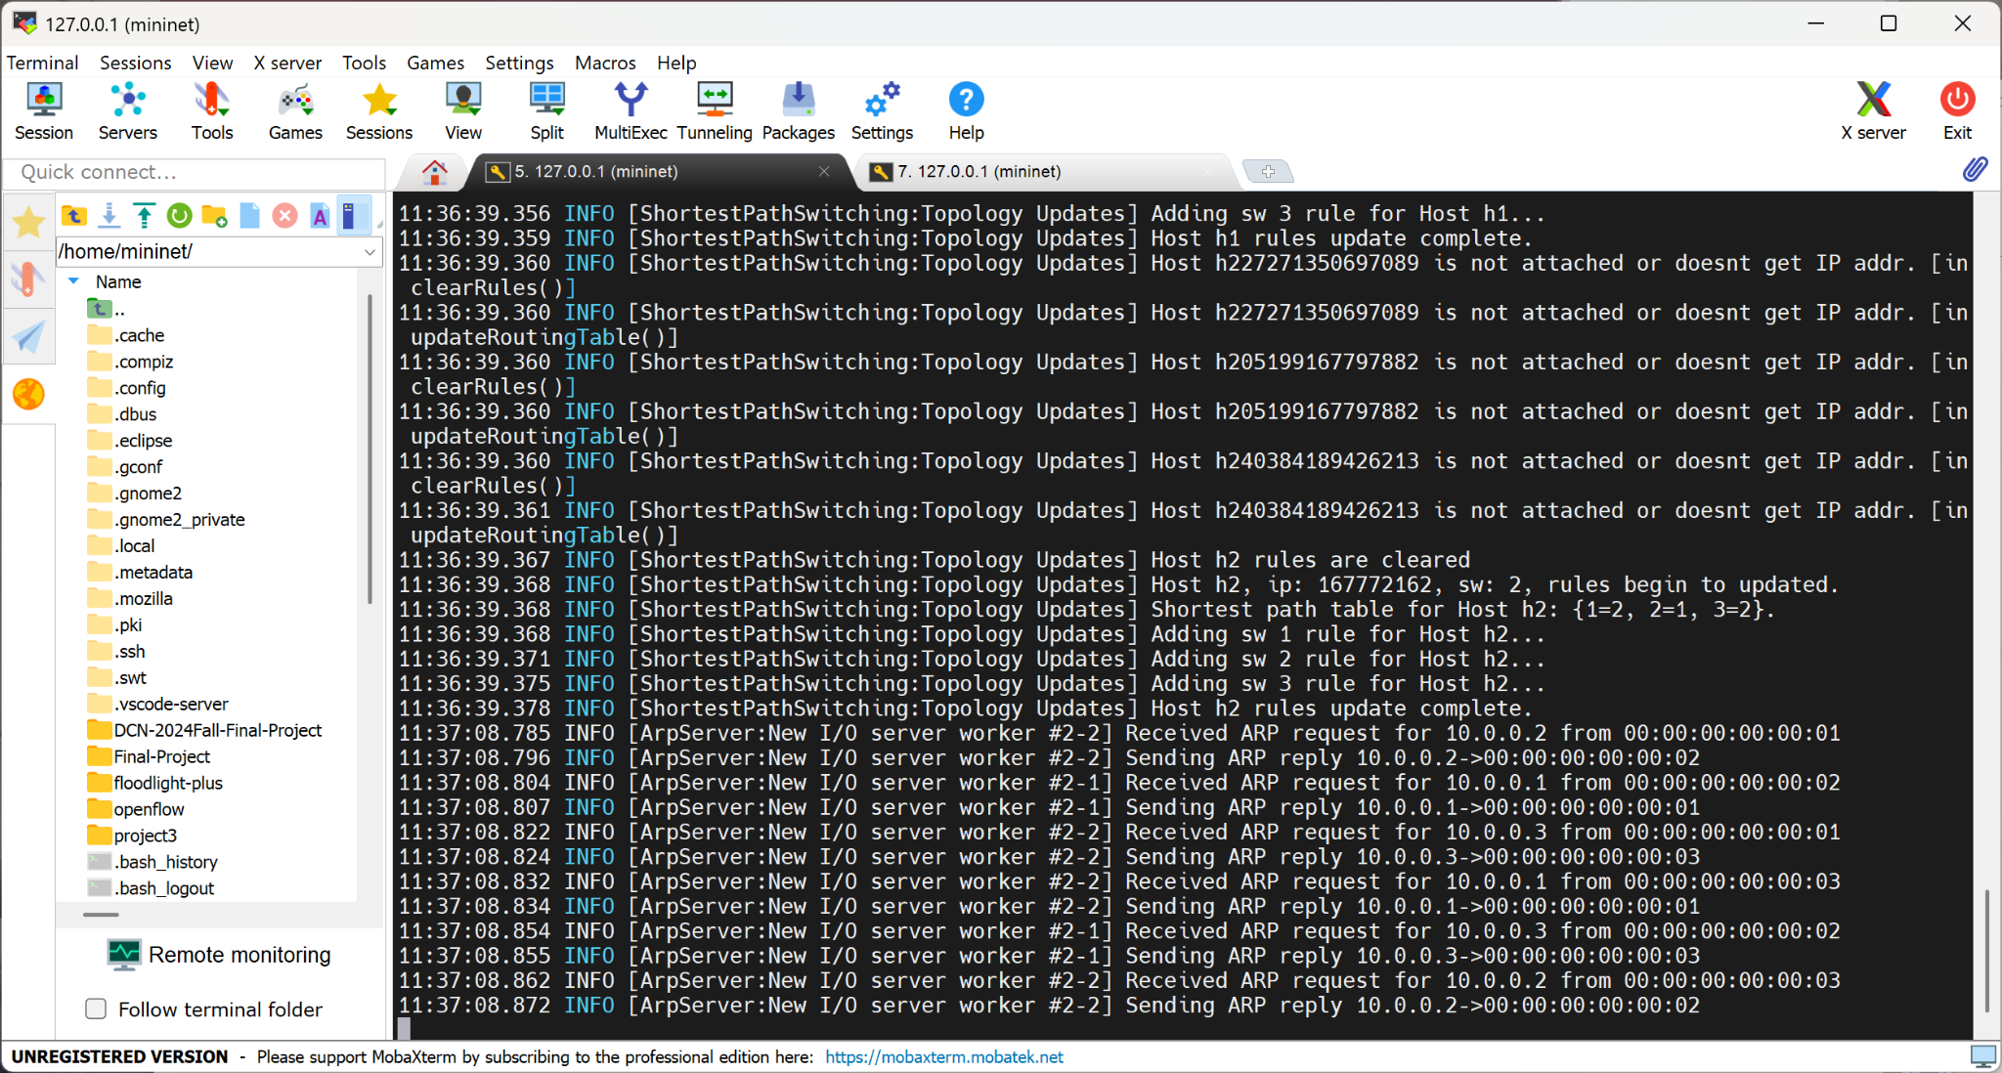

Start Floodlight with only `sps_balabce.prop` (sps with load balancer):

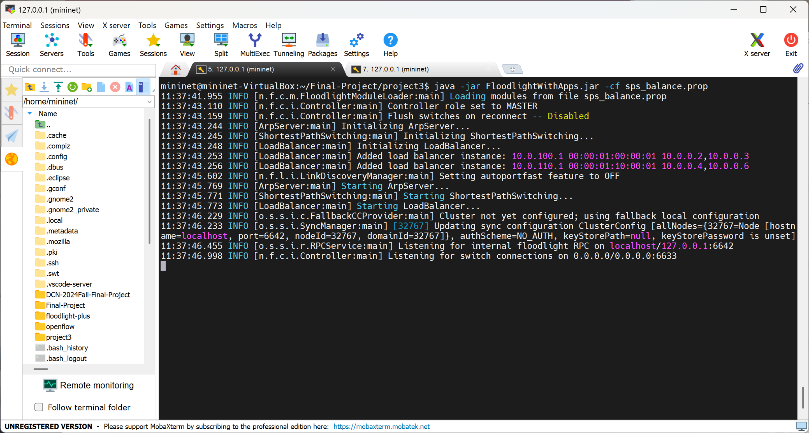

Restart mininet with assign1:

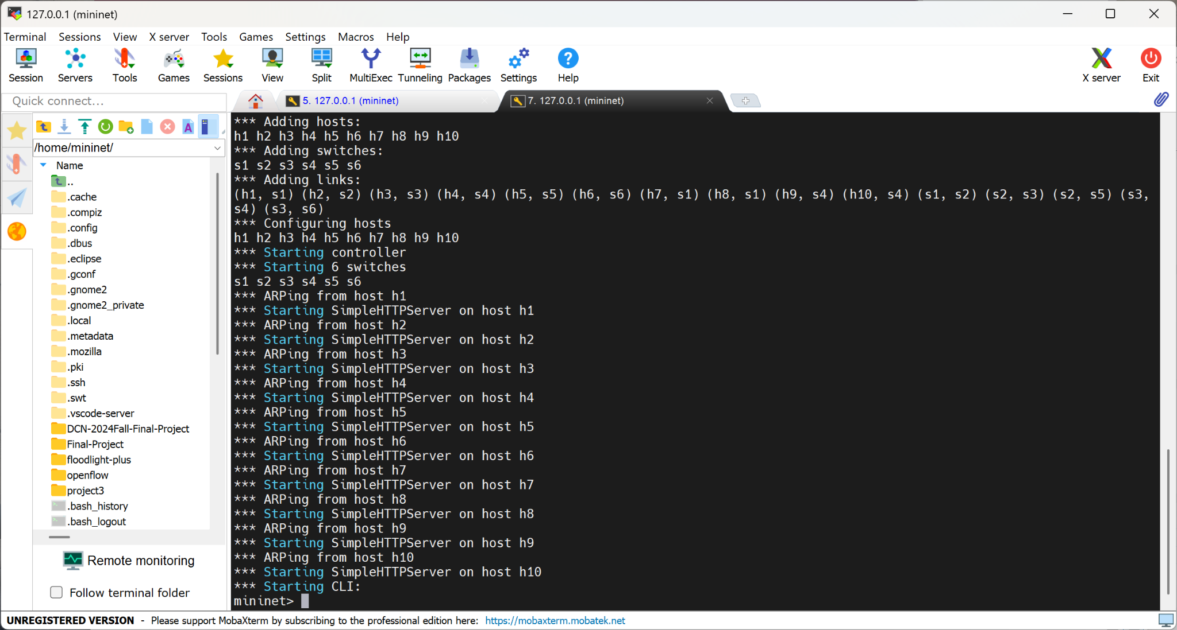

Run `pingall`:

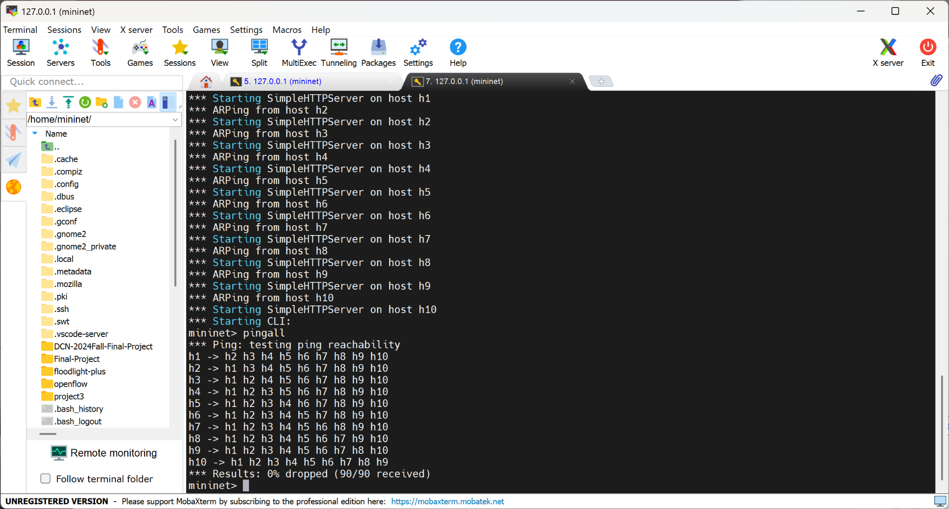

Corresponding Floodlight log (only some of logs are added here for simplicity):  
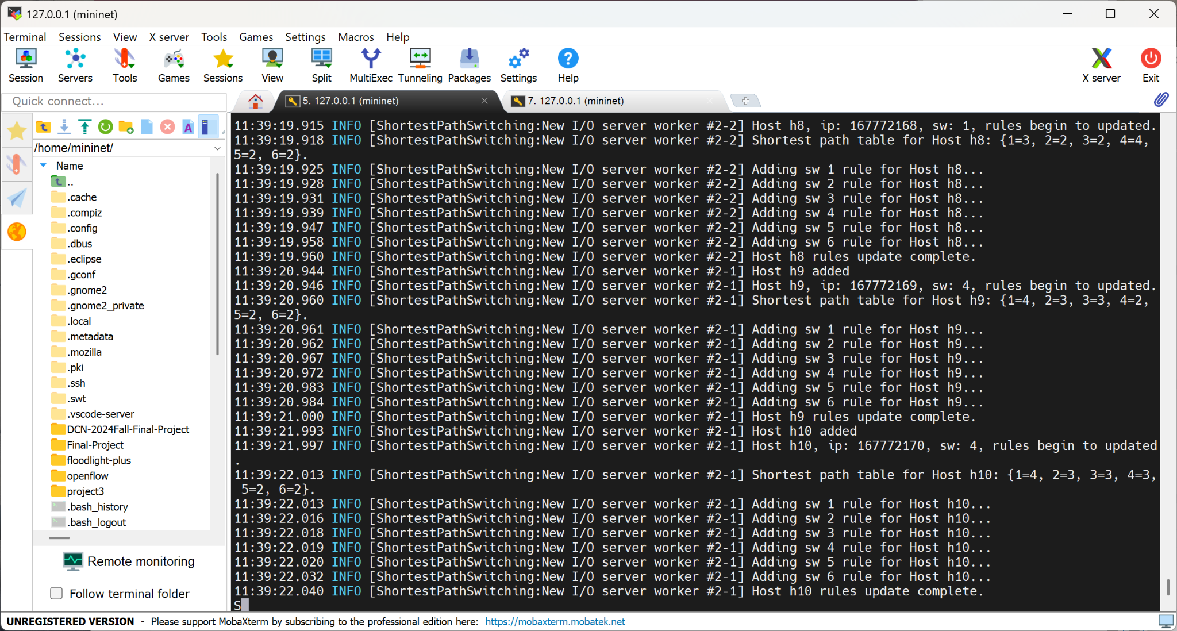

Test link up and down:  
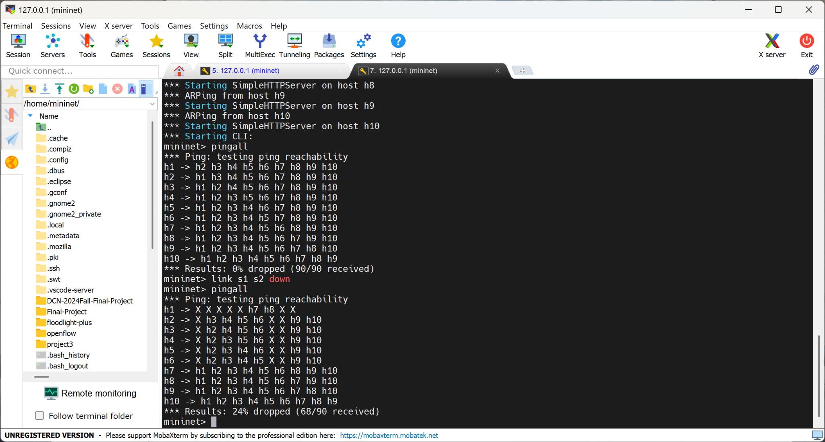

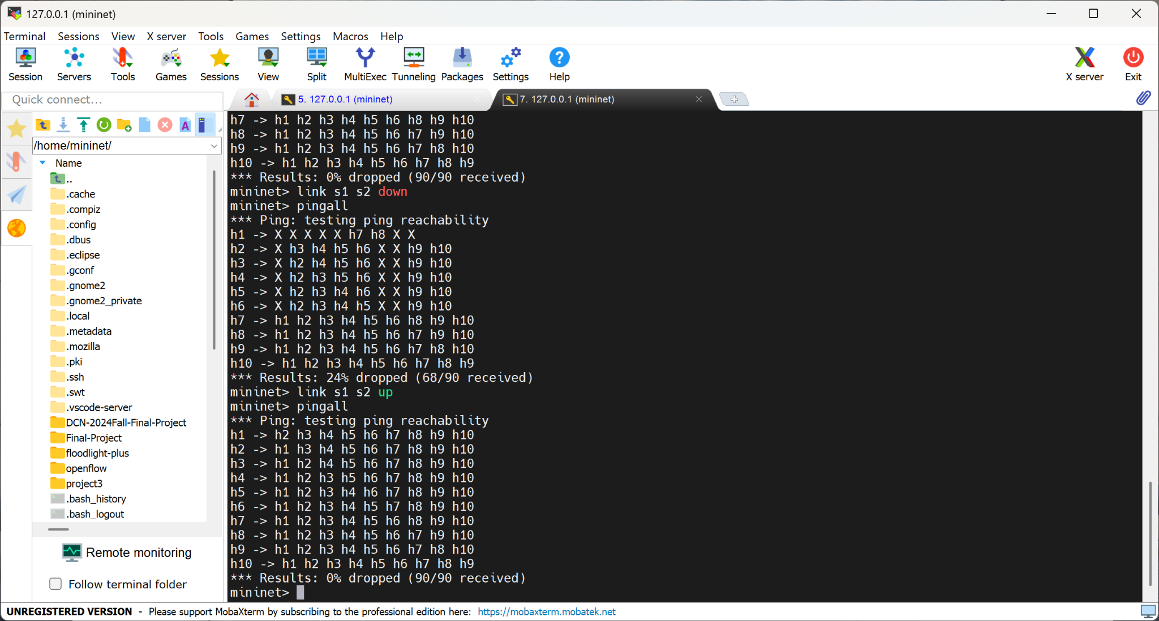

Corresponding flow table:  
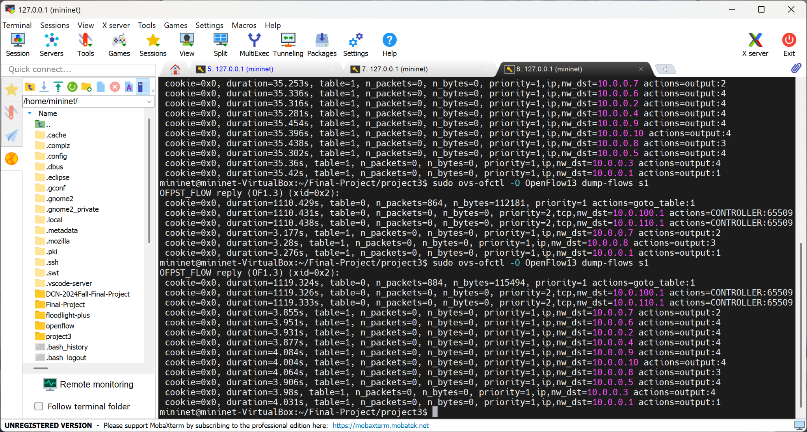

Test load balancer:  
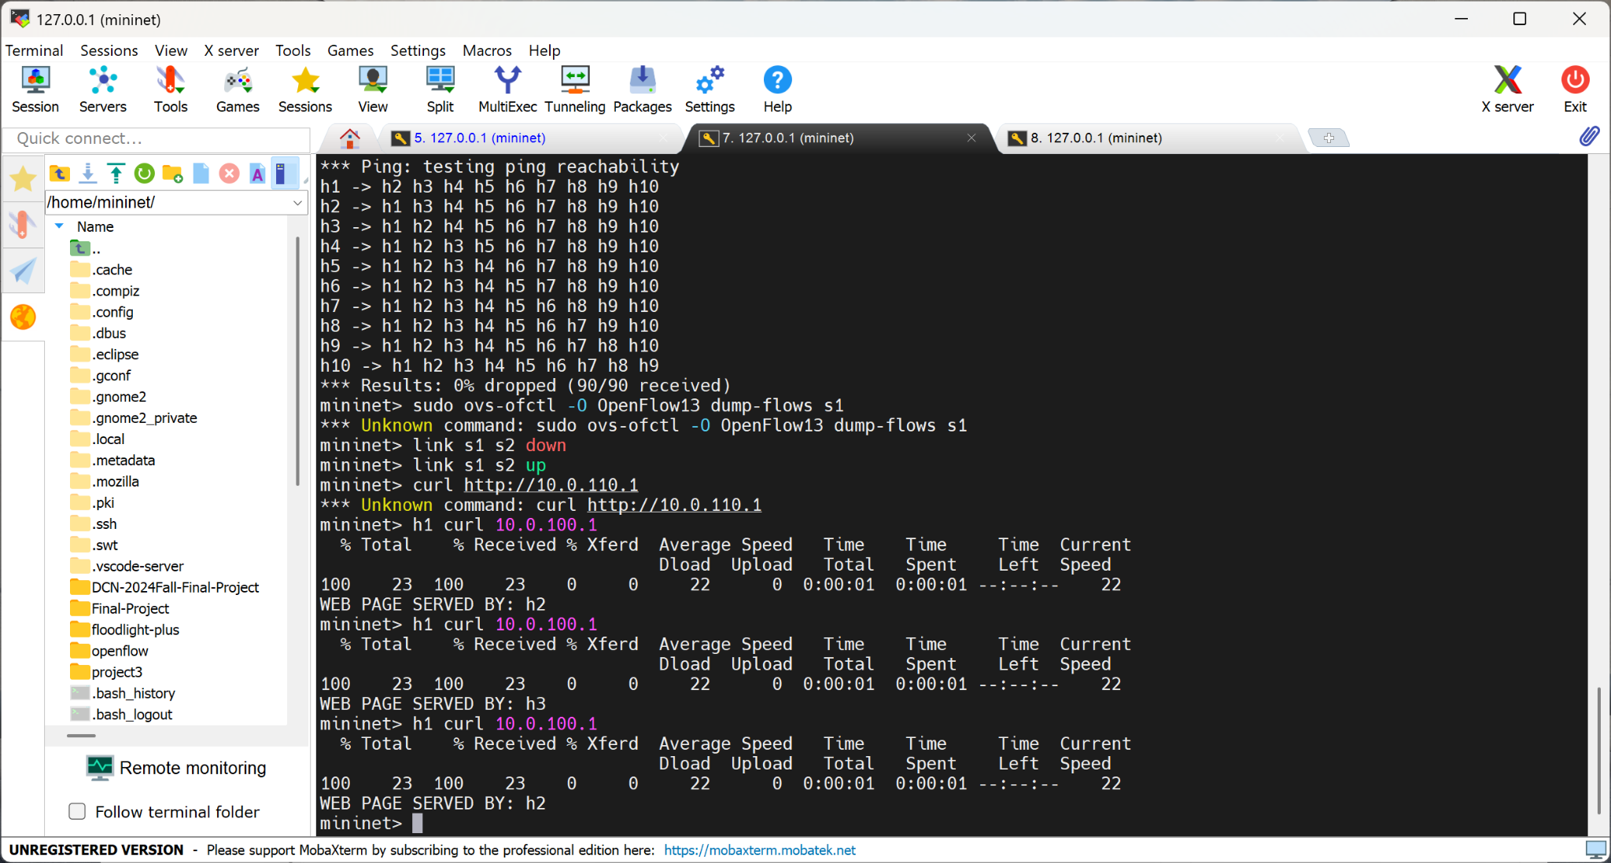

## Conclusion

In this project, we used SDN to implement both network layer routing and load balance routing, demonstrating the programmability of SDN to configure a device in any layer.

The Network layer routing uses the Bellman-Ford algorithm on the distance table of the network topology to compute the shortest paths between host pairs. Rules for forwarding packets based on the destination host's IP address are installed in switches along the computed shortest paths. The load balance routing forwards ARP and TCP packets with virtual IPs as destination addresses to the controller and processes ARP requests, TCP SYN packets, and non-SYN TCP packets differently. The experiment evaluates the implementation of these two tasks in a simulated network, and the results confirm the correctness of the workflow in this project.

## Reference

Github: <https://github.com/yx-xyc/DCN-2024Fall-Final-Project>